Emotion Wheel
In the centre there are 7 basic emotions. You can use this to guide you to identify more specific emotions you are feeling. Research shows that an awareness of a wider spectrum of emotions, helps with regulating difficult emotions.
Getting to know how you feel diary

Nervous System Thermometer
The thermometer represents 3 main nervous system modes and the spaces in between them. At the top of the blue and the bottom of the green, you can imagine the thermometer loops round so each end meets each other. This helps you to connect your physical and emotional experiences. When you are familiar with the connection between the two, you can learn to better meet your body’s needs.

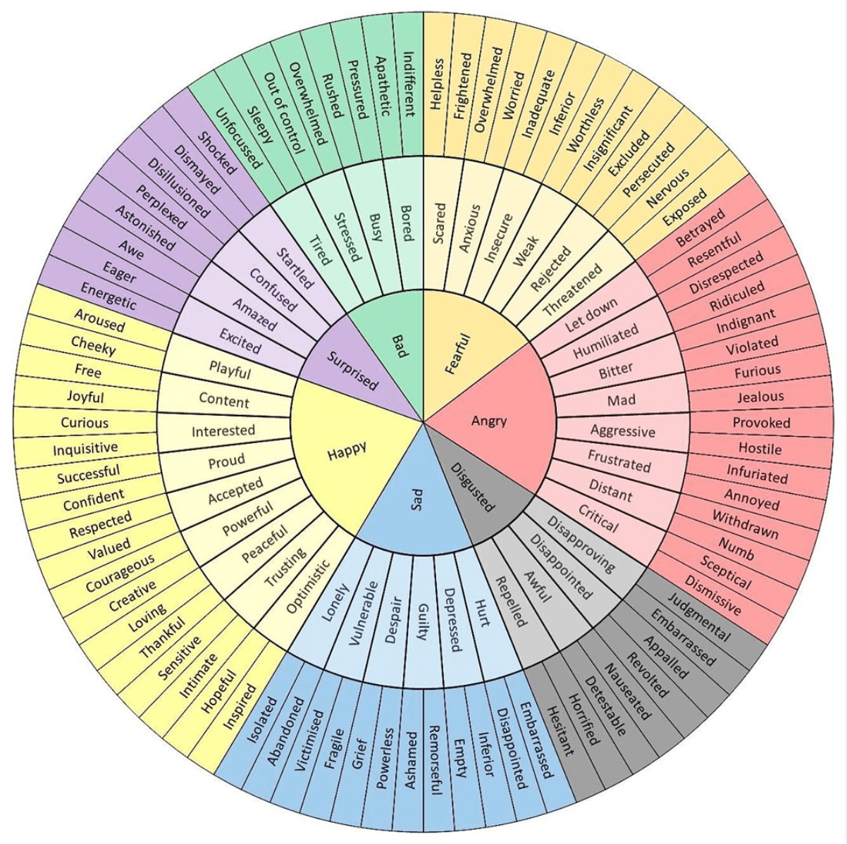
Shut down/ freeze mode
Also known as “dorsal vagal mode”. Your body is immobilised. Common feelings in this mode include feeling numbed, fatigue, brain fog, and unable to engage

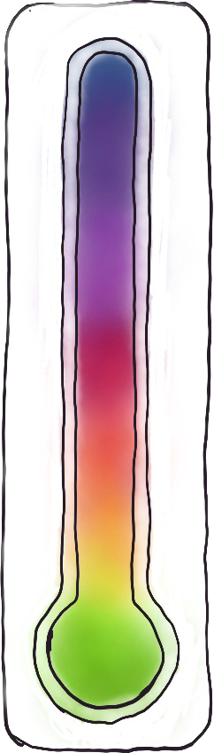

Stressed/ fight or flight mode
Also known as “sympathetic nervous system mode”. Your nervous system is mobilised to act. Common feelings in this mode include feeling stressed, urgent and overwhelmed

Content/ safe mode
Also known as “ventral vagal mode”. Here your nervous system is at an equilibrium with a sense of safety. You may feel relaxed, pleasure, calm and at ease.

 | Early morning  (first 3 hours of waking) | Mid-morning to early afternoon  (around 11am-2pm) | Afternoon  (2pm- 5pm) | Evening  (5-9pm) | Night-time  (9pm beyond)
 | Pick a feeling(s) that describes how you feel. Write it.  Pick a colour from the nervous system thermometer chart & colour the cell in. | Pick a feeling(s) that describes how you feel. Write it.  Pick a colour from the nervous system thermometer chart & colour the cell in. | Pick a feeling(s) that describes how you feel. Write it.  Pick a colour from the nervous system thermometer chart & colour the cell in. | Pick a feeling(s) that describes how you feel. Write it.  Pick a colour from the nervous system thermometer chart & colour the cell in. | Pick a feeling(s) that describes how you feel. Write it.  Pick a colour from the nervous system thermometer chart & colour the cell in.
Monday
Tuesday
Wednesday
Thursday
Friday
Saturday
Sunday

How to fill out this diary
The purpose
Our brains try to helpfully filter out non-priority issues for us. The problem is, that this can often involve emotional and physical information that it can be helpful to have an awareness of to some degree. In completely zoning this information out, we miss important opportunities to replenish ourselves in small ways that help to break down stress in the mind and body. This diary helps you to build awareness. It is not intended to be used for more than 2 weeks but instead to develop the ability to check in naturally throughout the day and week. We are not trying to micromanage our experience but to observe it. Scope for adjustment can come later.
What to do each day
Pick points in your day around the guidance given where you generally have a guaranteed thing that you are likely to do. For example, in the morning, you may regularly eat breakfast. Use these points of action in your day to plan to check in. Picking action points in your day makes it more likely that you will remember and not forget, however, it can be useful to set a set of reminders to begin with.
At the chosen time, notice how you are feeling. Don’t overthink your choice in picking where you sit on the nervous system thermometer chart. Notice what comes up first: emotions or physical feelings. See if you can identify words to describe them. Use the emotion wheel to explore further. Jot down the feelings in the box. Notice how your body is feeling, whether or not it feels connected to your emotions. Then finalise where you would put yourself on the nervous system thermometer chart. Pick the colour and fill the box with that colour.
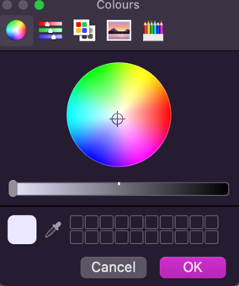
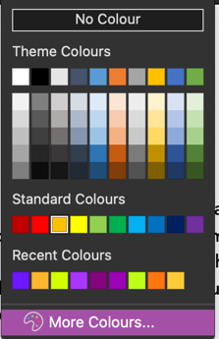
You can do this by going to the paint tin (in Word) and then clicking on the dropdown. Here you can select the colour on the spectrum that corresponds to the nervous system chart mode.
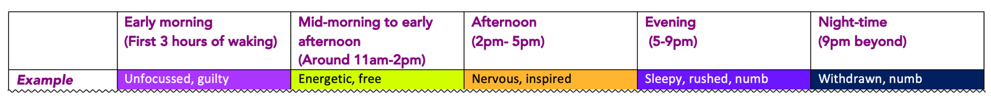
An example:

Questions | Answers
Was there anything surprising you found from doing this? If so, what?

What colours do I notice the most? What does this tell me?

What physical sensations are linked with what emotions?

How does it feel to label emotions in more detail?

Are there any actions you’ve been able to take (however small) because of checking in on how you are feeling?

Looking at the spread of colours and feelings, is there anything you need to prioritise to help balance your nervous system functioning out?

If yes, what could this look like?

